Your Association logo here

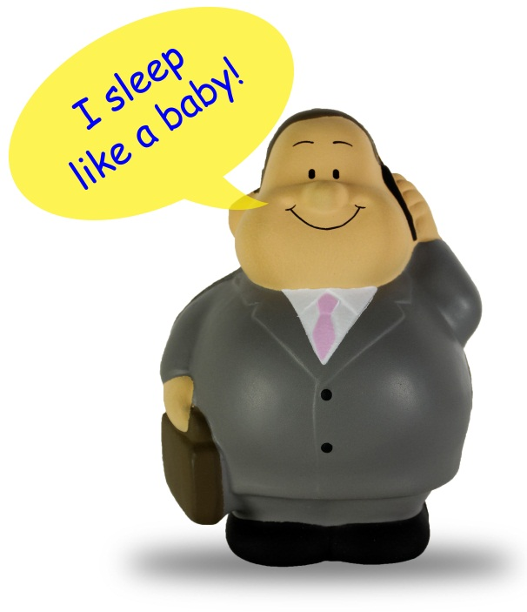
HR ISSUES KEEPING YOU AWAKE AT NIGHT?

Absenteeism, performance problems, hiring good people, performance reviews. Every business has people management challenges and insert your association name has the solution for you. We have licensed the TwoGreySuits HR service for our members as a part of your current membership package. (a $595 annual per company retail value)

Have a look at the video https://youtu.be/laJUjAksn-8 and then explore the HR Power Centre at www.twogreysuits.com. It contains everything you need for effective people management and, when you need answers fast, you can talk to a senior HR Professional 24/7 through the HR Hot Line. 1 800 661 9234

Signing up is hassle free. Just click on www.twogreysuits.com and sign in with your email address as username, (the email address the Association has for your company) and use the password _______, and you’re in!

Hassle-free, effortless HR Solutions for your business ...Because HR Happens.

For more information, call us at (Association phone number)

